**Work Breakdown Structure (WBS)**

**RAMS E-CAF:**

**A WEB-BASED CAFETERIA MANAGEMENT SYSTEM**

**FOR THE**

**ASIA PACIFIC COLLEGE**

**Asia Pacific College**

**3 Humabon Place, Magallanes**

**Makati City, 1232**

**May 2023**

# Introduction

The team created a Work Breakdown Structure (WBS) to help break down the project into manageable tasks and deliverables.

The WBS is a hierarchical decomposition of the project scope that organizes and defines the total scope of the project. The complete set of deliverables to be accomplished and the elaborative structure for initiation, planning, execution, and documentation phases are outlined through it. Every segment consists of certain assignments and subtasks that require fulfillment to guarantee the triumphant accomplishment of the undertaking.

As the duration of a project develops, it is beneficial to develop a Work Breakdown Structure (WBS) for evaluating advancement. This tool serves not only for monitoring purposes but also helps in identifying any discrepancies within or outside the plan and making adjustments when necessary. Through the divide and conquer approach, wherein a task is divided into smaller units to be tackled step by step, the WBS facilitates a better route towards accomplishment of a project.

The Work Breakdown Structure presented here represents all the work required to complete this project.

# Outline View

The project consists of key work packages including creating a Project Charter, developing a Stakeholder Management Strategy, evaluating a Business Case, and obtaining approval from the project sponsor.

1. Rams E-Caf, Cafeteria Management System
   1. Initiation (SNTSDEV)
      1. Creating Project Team
      2. Brainstorming
      3. Search for Client
      4. Draft of Proposal
      5. Deliverable: Project Proposal
      6. Approval of Project Draft
      7. Revision of Project Proposal
      8. Project Adviser Request
      9. Final Presentation
      10. Milestone: Project Proposal Approval
   2. Planning (SSYADD)
      1. Design Thinking Stage Empathize
      2. Design Thinking Stage Define
      3. Design Thinking Stage Ideate
      4. Design Thinking Stage Prototype
      5. Design Thinking Stage Test
      6. Draft of Data Flow Diagram (DFD)
      7. Draft of Entity Relationship Diagram (ERD)
      8. Draft of Use Case Diagram
      9. Project Presentation
   3. Execution (SCSPROJ)
      1. Revision of DFD
      2. Revision of ERD
      3. Revision of Use Case Diagram
      4. Milestone: Website Prototype
      5. Adviser Meeting 1
      6. Face to Face Client Meeting
      7. Midterm Presentation
      8. Project Revision
      9. Development of Manage Accounts Function
      10. Development of Select Vendor Function
      11. Development of Manage Profile Function
      12. Development of Manage Order Function
      13. Development of Manage Reports Function
      14. Development of Manage Items Function
      15. Development of View Feedbacks Function
      16. Deliverable: Working Web Application
      17. Adviser Meeting 2
      18. Finals Defense
      19. Milestone: Rams E-Caf Website
   4. Documentation (PROJMAN)
      1. Create Project Charter
      2. Create Stakeholder Management Strategy
      3. Create Business Case
      4. Deliverable: Submit Project Charter, Stakeholder Management Strategy, and Business Case
      5. Project Sponsor Reviews Documents
      6. Milestone: Documents Signed/Approved

# Hierarchical Structure

The project utilizes a hierarchical structure to efficiently organize and manage tasks, enabling clear coordination, resource allocation, and progress tracking. This structure fosters effective communication, decision-making, and risk mitigation, promoting collaboration and successful outcomes.

|  |  |  |
| --- | --- | --- |
| Level | WBS Code | Element Name |
| 1 | 1 | Rams E-Caf, Cafeteria Management System |
| 2 | 1.1 | Initiation (SNTSDEV) |
| 3 | 1.1.1 | Creating Project Team |
| 3 | 1.1.2 | Brainstorming |
| 3 | 1.1.3 | Search for Client |
| 3 | 1.1.4 | Draft of Proposal |
| 3 | 1.1.5 | Deliverable: Project Proposal |
| 3 | 1.1.6 | Approval of Project Draft |
| 3 | 1.1.7 | Revision of Project Proposal |
| 3 | 1.1.8 | Project Adviser Request |
| 3 | 1.1.9 | Final Presentation |
| 3 | 1.1.10 | Milestone: Project Proposal Approval |
| 2 | 1.2 | Planning (SSYADD) |
| 3 | 1.2.1 | Design Thinking Stage 1 Empathize |
| 3 | 1.2.2 | Design Thinking Stage 2 Define |
| 3 | 1.2.3 | Design Thinking Stage 3 Ideate |
| 3 | 1.2.4 | Design Thinking Stage 4 Prototype |
| 3 | 1.2.5 | Design Thinking Stage 5 Test |
| 3 | 1.2.6 | Draft of Data Flow Diagram (DFD) |
| 3 | 1.2.7 | Draft of Entity Relationship Diagram (ERD) |
| 3 | 1.2.8 | Draft of Use Case Diagram |
| 3 | 1.2.9 | Project Presentation |
| 2 | 1.3 | Execution (SCSPROJ) |
| 3 | 1.3.1 | Revision of DFD |
| 3 | 1.3.2 | Revision of ERD |
| 3 | 1.3.3 | Revision of Use Case Diagram |
| 3 | 1.3.4 | Milestone: Website Prototype |
| 3 | 1.3.5 | Adviser Meeting 1 |
| 3 | 1.3.6 | Face to Face Client Meeting |
| 3 | 1.3.7 | Midterm Presentation |
| 3 | 1.3.8 | Project Revision |
| 3 | 1.3.9 | Development of Manage Accounts Function |
| 3 | 1.3.10 | Development of Select Vendor Function |
| 3 | 1.3.11 | Development of Manage Profile Function |
| 3 | 1.3.12 | Development of Manage Order Function |
| 3 | 1.3.13 | Development of Manage Reports Function |
| 3 | 1.3.14 | Development of Manage Items Function |
| 3 | 1.3.15 | Development of View Feedbacks Function |
| 3 | 1.3.16 | Deliverable: Working Web Application |
| 3 | 1.3.17 | Adviser Meeting 2 |
| 3 | 1.3.18 | Finals Defense |
| 3 | 1.3.19 | Milestone: Rams E-Caf Website |
| 2 | 1.4 | Documentation (PROJMAN) |
| 3 | 1.4.1 | Create Project Charter |
| 3 | 1.4.2 | Create Stakeholder Management Strategy |
| 3 | 1.4.3 | Create Business Case |
| 3 | 1.4.4 | Deliverable: Submit Project Charter, Stakeholder Management Strategy, and Business Case |
| 3 | 1.4.5 | Project Sponsor Reviews Documents |
| 3 | 1.4.6 | Milestone: Documents Signed/Approved |

# Tabular View

The team made a tabular view to present key project components, milestones, and timelines in a structured format, facilitating easy reference, tracking, and analysis.

|  |  |  |
| --- | --- | --- |
| Level 1 | Level 2 | Level 3 |
| 1 Rams E-Caf, Cafeteria Management System | 1.1 Initiation (SNTSDEV) | 1.1.1 Creating Project Team  1.1.2 Brainstorming  1.1.3 Search for Client  1.1.4 Draft of Proposal  1.1.5 Deliverable: Project Proposal  1.1.6 Approval of Project Draft  1.1.7 Revision of Project Proposal  1.1.8 Project Adviser Request  1.1.9 Final Presentation  1.1.10 Milestone: Project Proposal Approval |
| 1.2 Planning (SSYADD) | 1.2.1 Design Thinking Stage Empathize  1.2.2 Design Thinking Stage Define  1.2.3 Design Thinking Stage Ideate  1.2.4 Design Thinking Stage Prototype  1.2.5 Design Thinking Stage Test  1.2.6 Draft of Data Flow Diagram (DFD)  1.2.7 Draft of Entity Relationship Diagram (ERD)  1.2.8 Draft of Use Case Diagram  1.2.9 Project Presentation |
| 1.3 Execution (SCSPROJ) | 1.3.1 Revision of DFD  1.3.2 Revision of ERD  1.3.3 Revision of Use Case Diagram  1.3.4 Milestone: Website Prototype  1.3.5 Adviser Meeting 1  1.3.6 Face to Face Client Meeting  1.3.7 Midterm Presentation  1.3.8 Project Revision  1.3.9 Development of Manage Accounts Function  1.3.10 Development of Select Vendor Function  1.3.11 Development of Manage Profile Function  1.3.12 Development of Manage Order Function  1.3.13 Development of Manage Reports Function  1.3.14 Development of Manage Items Function  1.3.15 Development of View Feedbacks Function  1.3.16 Deliverable: Working Web Application  1.3.17 Adviser Meeting 2  1.3.18 Finals Defense  1.3.19 Milestone: Rams E-Caf Website |
| 1.4 Documentation (PROJMAN) | 1.4.1 Create Project Charter  1.4.2 Create Stakeholder Management Strategy  1.4.3 Create Business Case  1.4.4 Deliverable: Submit Project Charter, Stakeholder Management Strategy, and Business Case  1.4.5 Project Sponsor Reviews Documents  1.4.6 Milestone: Documents Signed/Approved |

# Tree Structure View

Our project employs a tree structure view to visually represent the hierarchical relationships and dependencies among project tasks and subtasks, providing a clear and intuitive overview of the project's organizational structure.

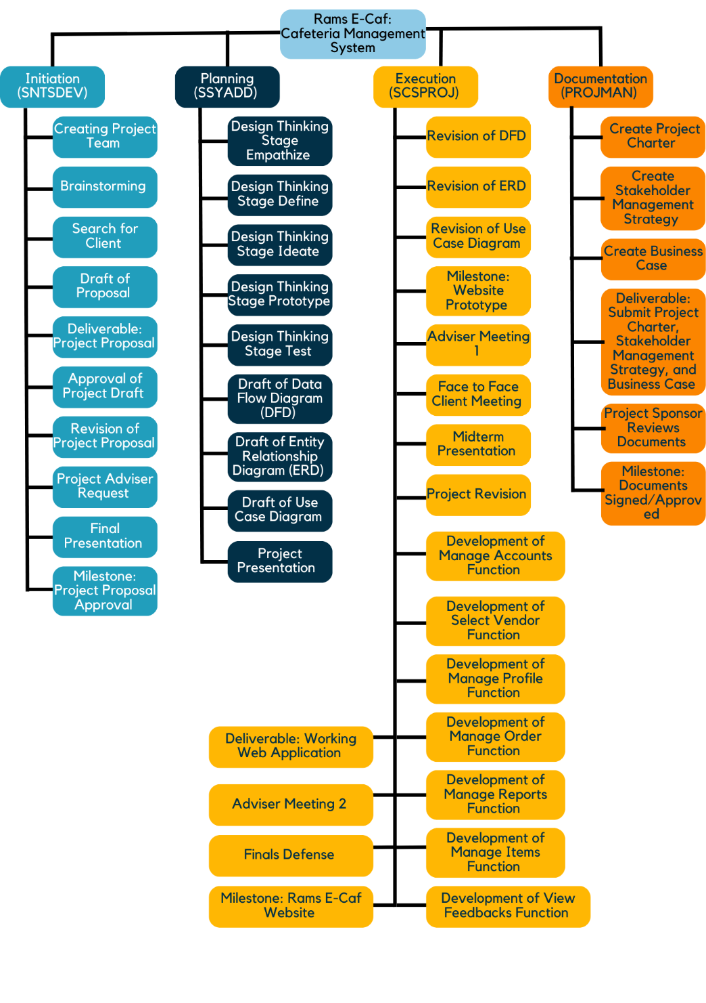

# WBS Dictionary

This WBS dictionary provides a comprehensive reference that defines and describes each work package, including its deliverables, activities, resources, and dependencies, ensuring clarity and consistency in project understanding.

|  | WBS Code | Definition | WBS Code |
| --- | --- | --- | --- |
| 1 | 1 | Rams E-Caf, Cafeteria Management System | All work to implement a new Cafeteria Management System |
| 2 | 1.1 | Initiation (SNTSDEV) | The work to initiate the project. |
| 3 | 1.1.1 | Creating Project Team | Working group to evaluate solution sets and make recommendations. |
| 3 | 1.1.2 | Brainstorming | Project Team discuss different problems that needs to be addressed |
| 3 | 1.1.3 | Search for Client | Search for a client that preceded over the problem |
| 3 | 1.1.4 | Draft of Proposal | Develop project proposal addressing problem and proposed solution |
| 3 | 1.1.5 | Deliverable: Project Proposal | Presentation of the project proposal is a requirement for the SNTSDEV Course |
| 3 | 1.1.6 | Approval of Project Draft | Project Draft got approved by course instructor |
| 3 | 1.1.7 | Revision of Project Proposal | Project team revises project proposal according to comments |
| 3 | 1.1.8 | Project Adviser Request | Project manager searches for a project adviser that fits the project |
| 3 | 1.1.9 | Final Presentation | Presentation of the final project proposal to ensure quality of project |
| 3 | 1.1.10 | Milestone: Project Proposal Approval | After revisions according to new comments, approval will start the planning phase for the project team |
| 2 | 1.2 | Planning (SSYADD) | The work needed to design the system |
| 3 | 1.2.1 | Design Thinking Stage 1 Empathize | Project team will interview stakeholders |
| 3 | 1.2.2 | Design Thinking Stage 2 Define | Project team will determine the root cause |
| 3 | 1.2.3 | Design Thinking Stage 3 Ideate | Project team works on a solution for the problem |
| 3 | 1.2.4 | Design Thinking Stage 4 Prototype | Project team works on a basic prototype for designing functions |
| 3 | 1.2.5 | Design Thinking Stage 5 Test | Project team will have the stakeholders test the prototype |
| 3 | 1.2.6 | Draft of Data Flow Diagram (DFD) | Project team works on the DFD |
| 3 | 1.2.7 | Draft of Entity Relationship Diagram (ERD) | Project team works on the ERD |
| 3 | 1.2.8 | Draft of Use Case Diagram | Project team works on the Use Case Diagram |
| 3 | 1.2.9 | Project Presentation | Project team led by the project manager presents results of Design thinking and diagrams |
| 2 | 1.3 | Execution (SCSPROJ) | The work needed for building, revision of designs, and documentations of the project |
| 3 | 1.3.1 | Revision of DFD | Project Team revises DFD |
| 3 | 1.3.2 | Revision of ERD | Project Team finalizes ERD |
| 3 | 1.3.3 | Revision of Use Case Diagram | Project Team finalizes Use Case Diagram |
| 3 | 1.3.4 | Milestone: Website Prototype | Project team, programmer designs basic website prototype |
| 3 | 1.3.5 | Adviser Meeting 1 | Project team Meets with Project Adviser to better align project goals |
| 3 | 1.3.6 | Face to Face Client Meeting | Project team Meets with project client/sponsor and provide demo of the basic prototype for comments on functions |
| 3 | 1.3.7 | Midterm Presentation | Project team led by the project manager will present Diagrams and Documents |
| 3 | 1.3.8 | Project Revision | Project team will revise the diagrams and document, and website according to comments |
| 3 | 1.3.9 | Development of Manage Accounts Function | Work needed to provide the admin all access to everyone’s accounts |
| 3 | 1.3.10 | Development of Select Vendor Function | Work needed to provide customers vendor selection |
|  | 1.3.11 | Work needed for customers to view their profile on the website | 1.3.11 |
|  | 1.3.12 | Work needed for food concessionaires to better manage their online orders | 1.3.12 |
|  | 1.3.13 | Work needed for the food concessionaires to better view reports | 1.3.13 |
|  | 1.3.14 | Work needed for the food concessionaires to better manage their food stocks | 1.3.14 |
|  | 1.3.15 | Work needed for the admin and food concessionaires to view feedback given by customers | 1.3.15 |
|  | 1.3.16 | Working Web Application is a deliverable fort the SCSPROJ course | 1.3.16 |
|  | 1.3.17 | Project Team meets with the project adviser for constructive criticism before the final defense. | 1.3.17 |
|  | 1.3.18 | Project Team led by the Project Manager will defend the project in front of a panel | 1.3.18 |
|  | 1.3.19 | Project team produced a working Cafeteria Management System | 1.3.19 |
|  | 1.4 | Work needed to complete all of the documentations | 1.4 |
|  | 1.4.1 | Project team works on the Project Charter | 1.4.1 |
|  | 1.4.2 | Project team works on the Stakeholder Management Strategy | 1.4.2 |
|  | 1.4.3 | Project Team works on the Business Case | 1.4.3 |
|  | 1.4.4 | All documents are to be submitted to the project sponsor to be reviewed and approved | 1.4.4 |
|  | 1.4.5 | Project Sponsor/Client reviews the documents mentioned | 1.4.5 |
|  | 1.4.6 | The Project Sponsor approved the documents to proceed with the Cafeteria Management System | 1.4.6 |

# Glossary of Terms

The Glossary of Terms serves as a concise reference, providing clear definitions and explanations for key project-related terminology, promoting shared understanding and effective communication throughout the project.

Level of Effort: Level of Effort (LOE) is how much work is required to complete a task.

WBS Code: A unique identifier assigned to each element in a Work Breakdown Structure for the purpose of designating the element’s hierarchical location within the WBS.

Work Package: A Work Package is a deliverable or work component at the lowest level of its WBS branch.

WBS Component: A component of a WBS which is located at any level. It can be a Work Package or a WBS Element as there's no restriction on what a WBS Component is.

WBS Element: A WBS Element is a single WBS component, and its associated attributes are located anywhere within a WBS. A WBS Element can contain work, or it can contain other WBS Elements or Work Packages.

# 